OCEANA COUNTY

**4-H SMALL MARKET**

**DUCKS RECORD BOOK- 2023**

**(for ages 8 and up)**

As a member of the Small Market Animal Project, you are required to submit your records as part of an educational project notebook in order to show your animal at the Oceana County Fair. **This notebook must be shown to the Poultry Superintendent or designated Small Market Weighmaster at the time of weigh-in and then entered by you in the Educational Notebook Division at the Oceana County Fair on Entry Day.**

**AGE: ___________**

The age you enter depends on how old you were on January 1, 2023

**NUMBER OF YEARS IN PROJECT: _____________**

Use this page as the first page of your project record book. Fill it out completely.

**Please print or type neatly**.

# NAME ______________________________________________________________________

**4-H CLUB ___________________________________________________________________**

##### LEADER _____________________________________________________________________

**DATE RECORDS STARTED ____________________ DATE ENDED __________________**



**JUDGE’S SCORE/COMMENT SHEET**

**(PLEASE DO NOT REMOVE, PLACE THIS SHEET IN SHEET PROTECTOR OR GLUE TO COVER). This sheet must be keep free to the judge to write their comments.**

This sheet should help each 4-H’er understand their ribbon placing.

A. **Specific educational value or worth**

___ All questions were answered completely

___ All calculations were correct

___ Calculations were incorrect

___ Questions were not completely answered

___ Questions were not answered (missed questions)

B. **Notebook contains all project records**

___ Notebook contained all project records and were fully completed

___ Notebook contained additional project related information (research

materials etc.)

___ Project records were incomplete

___There was no additional project related information

C. **Accuracy, neatness and general appearance**

___Notebook was neat in appearance (typed/hand printed)

___ Notebook pages were clean and stain free

___Notebook pages were in order and complete

___Notebook pages were out of order and missing pages

___Notebook was difficult to read and messy

___Notebook had wrinkled and stained pages

Other Comments: _____________________________________________________________________________________

_____________________________________________________________________________________

_____________________________________________________________________________________

2023- SMA DUCKS PAGE 2

## OBJECTIVES

1. Develop desirable work habits, sportsmanship, and ability to cooperate and express ideas through participation in projects, discussions, method demonstrations, judging teams, and exhibits.
2. Experience the pride and responsibility of leasing/owning and caring for poultry.
3. Learn how to feed, fit, show, breed and raise poultry.
4. Learn proper handling procedures to prevent injuries to 4-H members and their poultry projects.
5. Appreciate and use scientific information in poultry production and marketing.
6. Improve knowledge of grading, marketing and merchandising of poultry and poultry products.
7. Improve knowledge of the nutritive value of poultry meat and eggs and how they contribute toward good health.
8. Learn the importance of the poultry industry to the local, state, and national economies.
9. Acquire information on the opportunity that poultry offers as a career.

This record book is part of your Small Market Ducks project. By keeping records up-to-date you will be able to see how much progress you make as you set Goals and work to accomplish them. Write or type neatly and clearly. Please keep the pages in order. Feel free to add extra pages at the end of your notebook.

SCORING CRITERIA

The following breakdown will be used during the judging process of all market livestock notebooks:

A. Specific educational value or worth **30%**

B. Creative way of showing what has been learned **10%**

C. Notebook contains all project records **50%**

D. Accuracy, neatness and general appearance **10%**

2023- SMA Ducks PAGE 3

**JOURNAL OF CARE**

The SMAA Committee would like the judge to see the time and effort which you put into the care & management of your project.

Include the following:

* Feeding and watering practices
* Health practices and medicines (vaccinations, etc.)
* General Management (building a cage, cleaning living area, feed pans, etc.)

|  |
| --- |
| **DAILY- Things done once or twice a day** |
|  |
| **WEEKLY- Things done once or twice a week** |
|  |
| **MONTHLY- Things done once a month** |
|  |
| **YEARLY- Things done one time or occasionally throughout the year** |
|  |

2023- SMA DUCKS PAGE 4

**Describe the type of Ducks being used in this project. List breed and variety. Why did you choose this breed?**

______________________________________________________________________________

______________________________________________________________________________

______________________________________________________________________________

______________________________________________________________________________

______________________________________________________________________________

## WEIGHT CHART

|  |  |  |
| --- | --- | --- |
| Date | Age | **Weight** |
|  |  |  |
|  |  |  |
|  |  |  |
|  |  |  |
|  |  |  |
|  |  |  |

**FINAL WEIGHT (FW)___________ AGE__________ DATE___________**

2023- SMA DUCKS PAGE 5

## EXPENSES

##### (A) Cost of ducklings $_______________________

|  |  |  |  |
| --- | --- | --- | --- |
| **DATE** | LBS. OF FEED | FEED - VARIETY | COST |
|  |  |  | **$** |
|  |  |  |  |
|  |  |  |  |
|  |  |  |  |
| **(B)** |  | **TOTAL SPENT ON FEED** | **$** |

|  |  |  |
| --- | --- | --- |
| **DATE** | OTHER EXPENSES, VET, SUPPLIES, HOUSING, ETC. | COST |
|  |  | **$** |
|  |  |  |
|  |  |  |
|  |  |  |
| **(C)** | **TOTAL SPENT ON OTHER EXPENSES** | **$** |

##### GRAND TOTAL OF ALL EXPENSES (TE): $ _______________________

**(total of A+B+C)**

**_______________ ÷ _________________ = ______________________________________**

Total Expenses **(TE)** Final Weight **(FW)** Break Even Price **(BE)**

(total cost per pound to raise your animal)

***\*\* The breakeven price is the price that you need to get at the***

***Small Market animal auction in order to not lose money on your market project \*\****

2023- SMA DUCKS PAGE 6

**MARKETING**

One of the most important parts of any market animal project is marketing; this is how you get someone to come to the auction to buy your animal. It may include things such as writing letters and talking to possible buyers.

* What did you do to market your animal?
* If you had a market project in the past what did you do differently this year?

_____________________________________________________________________________

_____________________________________________________________________________

______________________________________________________________________________

______________________________________________________________________________

**SHOWMANSHIP**

SHOWMANSHIP: (list 2 qualities of a good showperson):

1. __________________________________________________________________________

2. _________________________________________________________________________

NAME 2 WAYS YOU CAN IMPROVE IN SHOWMANSHIP:

1. ___________________________________________________________________________

2. ___________________________________________________________________________

LIST 1 WAY THAT YOU HELPED OR TAUGHT OTHERS THIS YEAR:

1. ___________________________________________________________________________

2023- SMA Duck Notebook Page 7

**PROJECT TERMS**- use the word bank to answer the questions (not all words will be used)

|  |  |  |  |  |  |  |  |  |  |  |  |  |
| --- | --- | --- | --- | --- | --- | --- | --- | --- | --- | --- | --- | --- |
| 1. |  |  |  |  |  |  |  |  |  | 11. |  | **WORD BANK**  BEAN  DUCKLING  GRIT  PREEN  WADDLE  BILL  FEATHERS  HEN  SADDLE  WATER  DRAKE  GIZZARD  MOULTING  SHOWMANSHIP  WATERFOWL  WEB |
|  |  |  |  |  |  |  |  |  |  |  |  |  |
|  |  |  |  |  | 6. |  |  | 14. |  |  |  |  |
|  |  |  | 10. |  |  |  |  |  |  |  |  |  |
|  |  |  |  |  |  |  |  |  |  |  |  |  |
|  |  | 3. |  |  |  |  |  |  |  |  |  |  |
|  |  |  |  |  |  |  | 4. |  | 12. |  |  |  |
|  |  |  |  |  |  |  |  |  |  |  |  |  |
|  |  | 9. |  |  |  |  |  |  |  |  |  |  |
|  |  |  |  |  |  |  |  |  |  |  |  |  |
|  | 2. |  |  |  |  |  |  | 13. |  |  |  |  |
|  |  |  |  |  |  |  |  |  |  |  |  |  |
|  |  |  |  |  |  |  |  |  |  |  |  |  |
|  |  |  |  |  | 7. |  |  |  |  |  |  |  |
| 5. |  |  |  |  |  |  |  |  |  |  |  |  |
|  |  | 8. |  |  |  |  |  |  |  |  |  |  |

**ACROSS:**

1. Ability to accept high or low placings gracefully and with honor
2. A young duck
3. The most important part of a duck’s diet
4. The skin growing between the toes of waterfowl
5. A female duck
6. The walking motion of most ducks
7. Epidermal outgrowths that together form the plumage of a fowl
8. An organ that contains grit for grinding up the grain poultry eats

**DOWN:**

1. The rear of the back of a male fowl

6. A water bird; esp., any of a family of birds consisting of ducks, geese

and swans

1. The process of shedding old feathers and regrowing new feathers
2. A raised, hard, bean shaped swelling on the end of the bill of waterfowl
3. How birds clean and comb their feathers
4. The horny mouth parts of waterfowl (forms the mouth & nose)
5. Sand and small pebbles eaten by a bird and used by its gizzard to grind up food

14. A male duck

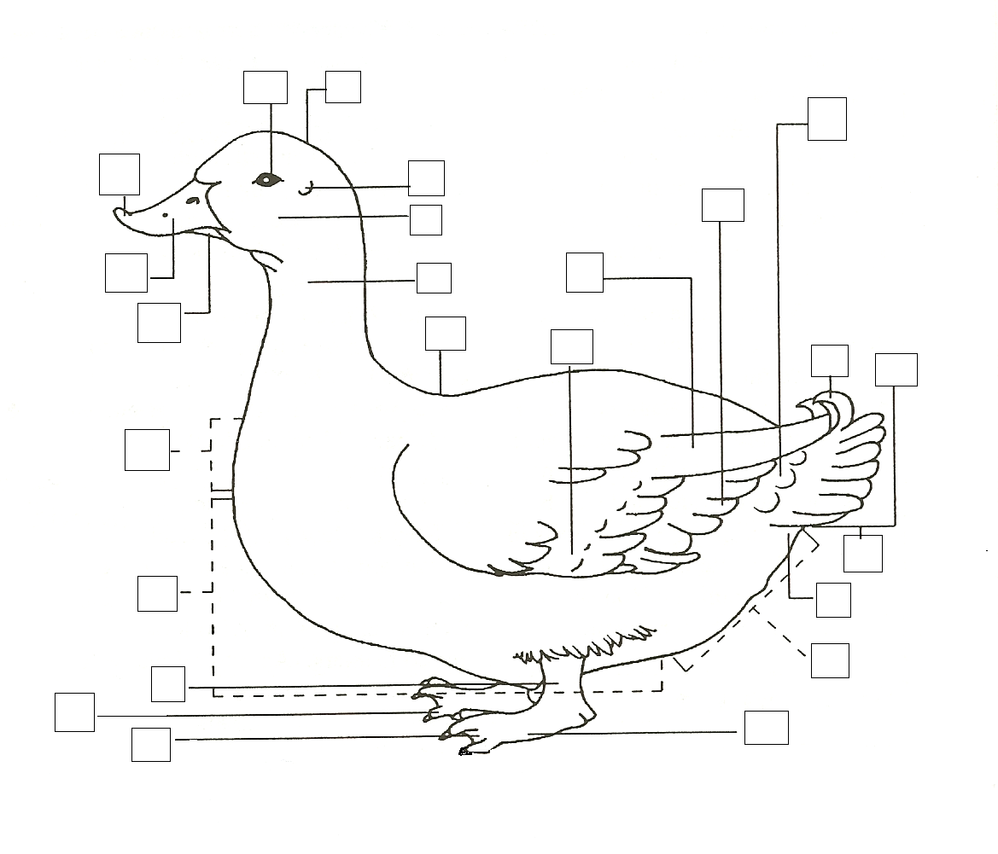

**IDENTIFY THE PARTS OF A DUCK**

(fill in the boxes in the above picture with the

letter corresponding to the correct part)

1. EYE M. FOOT
2. NECK N. CROWN
3. SECONDARY WING FEATHERS O. EAR
4. COVERTS P. BACK
5. WEB Q. UNDERTAIL COVERTS
6. CROP AREA R. TAIL COVERTS
7. BEAN S. BILL
8. TAIL T. BREAST AREA
9. PRIMARY WING FEATHERS U. CURLED SEX FEATHERS
10. LOWER BILL V. CHEEK
11. SHANK W. TOE
12. ABDOMINAL AREA

2023- SMA Duck Notebook Page 8

2023- SMA Duck Notebook Page 9

**POULTRY HEALTH-** answer the following questions to the best of your ability

1. What are three causes of poultry diseases? _________________________________

______________________________________________________________________________

2. What poultry diseases have your birds experienced? ________________________

______________________________________________________________________________

Why? ________________________________________________________________________

______________________________________________________________________________

3. What are three types of parasites? _________________________________________

______________________________________________________________________________

4. What poultry parasites have you seen? _____________________________________

______________________________________________________________________________

Where or when? _____________________________________________________________

______________________________________________________________________________

5. What are some common poultry health problems? _________________________

_____________________________________________________________________________

______________________________________________________________________________

6. What are three ways to prevent the most common poultry health problems?

______________________________________________________________________________

______________________________________________________________________________

______________________________________________________________________________

2023- SMA Duck Notebook Page 10

**NUMBER, IN ORDER, THE FOLLOWING SHOWMANSHIP STEPS**

_____ **Showing Width of Body**- Thumb and index finger of free hand placed across the bird’s Body directly behind the base of the wings to determine width and shape of the body.

_____ **Examining Under color**- Finger tips are used to gently pull tops of feathers “against the grain.”

_____ **Examining Head**- Bird raised to shoulder height with free hand used to move head bird turned and other side examined.

_____ **Measuring Width of Pubic Bones**- As many fingers of free hand as possible placed between the tips of the pubic bones.

_____ **Carrying the Bird**- Bird kept balanced and upright on the palm of the hand with head between the arm and body or if small against the carrier’s body. The other hand rests on the Bird’s back.

_____ **Examining the Wings**- First wing spread by grouping wing tip with free hand and pulling. Second wing examined by placing free hand across body of bird and applying pressure to last using joint with thumb and fingers to extend wing.

_____ **Examining Feet & Legs**- Bird held against show person’s body and freehand used to examine all parts. Bird swiveled to examine front of feet & legs.

_____ **Posing the Bird**- Bird shown on table in alert position with tail fluffed, head and beak raised, feathers smooth, wings in normal position.

_____ **Checking the Breast**- Bird’s head held downward with its back against show person Free hand used to measure breast bone and examine keel for straightness, breast blisters, indentations or other defects.

_____ **Measuring Depth of Abdomen**- Vent examined and depth of abdomen measured by placing as many fingers of the free hand as possible between the tip of the keel and the pubic bones.

(can be found in the Skills for Life Animal Science Series-Scratching the Surface)

2023- SMA Duck Notebook Page 11

**BIRDS DIGESTIVE SYSTEM**

(Write the number of the function with the correct part of the fowl)

1. Absorbs water from the digested food

2. This is the opening to the outside of the body.

common opening of the digestive, urinary and

reproductive systems.

3. Obtains food and water

4. Digestive appendages without an important

function.

5. “Acid Stomach” produces both acid and

enzymes that breaks down food.

6. Moistens and moves food.

7. Located after the proventriculus is the ventriculus

(stomach) that can grind hard food.

8. Structure into which the large intestine empties.

9. Carries food from mouth to the crop; can stretch

esophagus to allow passage of large pieces of

food.

10. Carries food away from the stomach and absorbs

nutrients from the food with the nutrients traveling

into the blood stream.

11. Is a place to store food that is undigested.

___ Beak or bill

___ Mouth cavity with tongue

____Expandable esophagus

____Esophagus with cropfood

___Large, distensible proventriculus

____Gizzard

____ Small Intestine

____ Large Intestine

____ Cecum

____ Cloaca

____ Vent

2021- SMA DUCKS PAGE 12

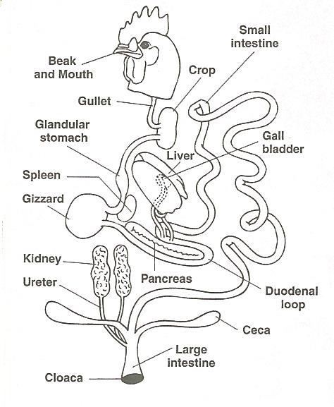

2023- SMA Duck Notebook Page 12

**PROJECT PROGRESS AND MANAGEMENT REPORT**

1. What did you enjoy doing the most with your project? ­_______________________

_______________________________________________________________________________

______________________________________________________________________________

_______________________________________________________________________________

2. What was the hardest part of your project?___________________________________

_______________________________________________________________________________

_______________________________________________________________________________

_______________________________________________________________________________

3. Will you do the market poultry project again? ____________________

Why or Why not? ___________________________________________________________

_______________________________________________________________________________

_______________________________________________________________________________

4. Would you recommend the breed that you chose for a market project? _______

Why or Why not? ___________________________________________________________

_______________________________________________________________________________

_______________________________________________________________________________

2023- SMA DUCKS PAGE 13

**The 4-H Pledge**

(fill in the blanks)

***I pledge…***

**My head to clearer _____________________,**

**My heart to greater _____________________,**

**My hands to larger _____________________,**

**And my health to better ________________.**

**For my ____________, My __________________,**

**My_______________, and my ______________.**

**The 4-H MOTTO: __________________________________________________.**

**FIND, AND CIRCLE, THE FOLLOWING “4-H” WORDS IN THE PUZZLE BELOW**

|  |  |  |  |  |  |  |  |  |  |  |  |  |
| --- | --- | --- | --- | --- | --- | --- | --- | --- | --- | --- | --- | --- |
| W | E | T | H | E | P | E | O | P | L | H | I | N  **WORD BANK:**  **CARING**  **CHARACTER**  **CITIZENSHIP**  **COMMUNITY**  **GIVING**  **HANDS**  **HEAD**  **HEALTH**  **HEART**  **HONESTY**  **INTEGRITY**  **RESPECT**  **SPORTSMANSHIP**  **TRUST**  **TRUTH** |
| O | S | R | D | R | E | T | C | A | R | A | H | C |
| T | P | O | R | M | F | O | R | G | A | N | M | I |
| B | O | P | E | B | P | U | O | N | L | D | M | T |
| T | R | U | S | T | K | C | W | I | E | S | R | I |
| B | T | M | P | N | Z | G | W | V | S | P | I | Z |
| N | S | W | E | O | L | V | E | I | H | R | I | E |
| E | M | S | C | A | R | I | N | G | O | S | P | N |
| A | A | R | T | Y | W | M | O | Z | N | S | H | S |
| G | N | F | E | T | T | O | D | A | E | H | N | H |
| T | S | E | R | I | M | A | R | I | S | E | V | I |
| R | H | W | T | H | V | E | R | S | T | R | C | P |
| W | I | N | T | E | G | R | I | T | Y | H | U | E |
| E | P | O | B | A | L | I | C | R | E | N | W | A |
| D | D | P | H | R | K | I | L | O | R | I | C | L |
| H | E | A | L | T | H | M | J | C | H | A | W | R |
| N | Q | L | J | Y | T | I | N | U | M | M | O | C |

2023- SMA DUCKS PAGE 14

**MY 4-H STORY**

(Interesting things that happened to me and my animal this year, challenges, highlights of my year or anything else I would like to share about my

overall 4-H experience)

***POTENTIAL BUYERS NAMES***

As part of your 4-H Small Market Livestock Project, you must personally contact at least three potential buyers before the Oceana County Fair. You are encouraged to seek two new buyers that have not been asked or submitted before. **You also must have at least three different buyers than those of your siblings in the market livestock project.** Please confirm with your buyers their accurate mailing address (example: post office box vs. a street address). The information on page 15 must be completed and taken to the Oceana County MSU Extension Office on or before the due date where it will be **copied** and used to send out letters to your potential buyers. This page will remain in your notebooks. This is a Market Livestock Committee rule. Failure to comply will result in not being able to sell your animal in the 4-H Market Livestock Sale.

2023- SMA DUCKS Date: _______________

Page 15 Staff: _______________

**SMAA/ JUNIOR MARKET POTENTIAL BUYER’S LIST**

**DUCK PROJECT (AGES 9 & up))**

Name______________________________ Club_________________________

***Please print business names and complete addresses clearly.***

* 1. Contact Name ________________________________________________­­____

Business Name ____________________________________________________

**Mailing** Address _________________________City__­­­­­­­­__­­­­­­­_____________Zip_____

Phone _______________________ After Hours Phone______________________

Mailing Preference (Please Check One): Email ____ Postal Delivery ____

Email ____________________________________________________________

Signature__________________________________________________________

2. Contact Name ________________________________________________­­____

Business Name ____________________________________________________

**Mailing** Address _________________________City__­­­­­­­­__­­­­­­­_____________Zip_____

Phone _______________________ After Hours Phone______________________

Mailing Preference (Please Check One): Email ____ Postal Delivery ____

Email ____________________________________________________________

Signature__________________________________________________________

3. Contact Name ________________________________________________­­____

Business Name ____________________________________________________

**Mailing** Address _________________________City__­­­­­­­­__­­­­­­­_____________Zip_____

Phone _______________________ After Hours Phone______________________

Mailing Preference (Please Check One): Email ____ Postal Delivery ____

Email ____________________________________________________________

Signature__________________________________________________________

(Must be stamped by the MSU Extension Office)

2023- SMA DUCKS PAGE 16

**PICTURES OF YOUR PROJECT**

(Please use this page for your project pictures. Add additional pages if you would like. The judges appreciate you labeling the pictures so they know what the picture shows.)

***NON-CLUB* POINTS- JUNIOR/SMALL MARKET PROJECT**

***(This must be filled out by participant before presenting for signatures at the MSUE office)***

|  |  |  |  |  |
| --- | --- | --- | --- | --- |
| **MEETING NAME** | **LOCATION** | **DATE** | **POINTS** | **SIGNATURE OF LEADER, SUPERINTENDENT OR MSU STAFF** |
|  |  |  |  |  |
|  |  |  |  |  |
|  |  |  |  |  |
|  |  |  |  |  |
|  |  |  |  |  |
|  |  |  |  |  |
|  |  |  |  |  |
|  |  |  |  |  |
|  |  |  |  |  |
|  |  |  |  |  |

Please note: This form must be included with your record notebook and turned into the weigh master on entry day of the Fair. **BEFORE SEEKING SIGNATURES AT MSU EXTENSION – MEETING NAME AND DATE MUST BE COMPLETED** You need to accumulate **nine (9) points** to be allowed to sell your animal. **Six (6)** of these **nine (9) points** must come from club meetings. The **three (3)** non-club points must be earned from attending various 4-H events and activities. See your leader, the MSUE office, or online at <https://www.canr.msu.edu/oceana/oceana_county_4_h/oceana_4_h_market_livestock> for a listing of approved nonclub points.

**JUNIOR/SMALL MARKET PROJECT CLUB POINTS**

***(This must be filled out by participant before presenting for signatures at the MSUE office)***

|  |  |  |  |  |
| --- | --- | --- | --- | --- |
| **MEETING NAME** | **LOCATION** | **DATE** | **POINTS** | **SIGNATURE OF LEADER, SUPERINTENDENT OR MSU STAFF** |
|  |  |  |  |  |
|  |  |  |  |  |
|  |  |  |  |  |
|  |  |  |  |  |
|  |  |  |  |  |
|  |  |  |  |  |
|  |  |  |  |  |
|  |  |  |  |  |
|  |  |  |  |  |
|  |  |  |  |  |
|  |  |  |  |  |

Please note: This form must be included with your record notebook and turned into the weigh master on entry day of the Fair. You need to accumulate **nine (9) points** to be allowed to sell your animal. **Six (6)** of these **nine (9) points** must come from club meetings. The **three (3)** non-club points must be earned from attending various 4-H events and activities